**SIMULATION OF POLAR 3D PRINTER MACHINE**

**EXPT No : 4 DATE:**

**AIM:**

To simulate the construction of polar 3D printer and to get in-depth knowledge of mechatronics of polar 3D printers.

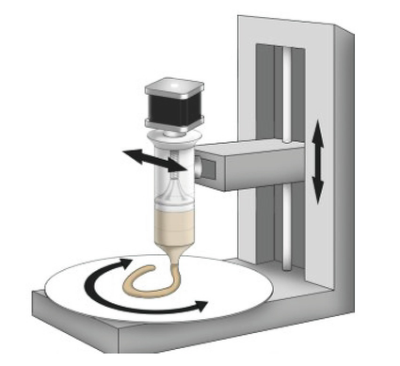

**REQUIREMENTS:**

* System - Windows 7 or higher, 1 GB RAM.

**PROCEDURE:**

**Assembly of Polar 3D Printer**

1. Select 'Assembly of Polar 3D Printer' from the visible list.
2. All the parts related to Polar 3D Printer will be shown on the screen.
3. Select the parts in sequence in which they are shown.
4. When the first part is selected then it will open in the blank space in the left side of the screen.
5. Further, when the correct part will be selected then it will get assembled with the previously selected part/parts.
6. If the user follows an incorrect sequence then a pop-up will appear on the screen showing the name of the part to be selected.

**Playing with Axes**

1. Move the r-axis slider and observe the movement of the r-axis assembly.
2. Move the y-axis slider and observe the movement of the y-axis assembly.
3. Move the z-axis slider and observe the movement of the z-axis assembly.

**OUTPUT:**

|  |  |
| --- | --- |
|  | Y-Axis Base :  The Y-axis base of a polar 3D printer is the rotating platform that supports the print bed. It is responsible for moving the print bed horizontally in order to create the desired shape. |
| Z-Axis Frame :  The Z-axis frame of a polar 3D printer is the vertical structure that supports the extruder assembly. It is responsible for moving the extruder up and down in order to deposit filament at the correct height. |
| Smooth Rods :  The smooth rods in a polar 3D printer are used to guide the movement of the print head and extruder assembly. |
| Motors :  Polar 3D printers typically use three motors to move the print head and print bed. The three motors are the X-axis motor, the Y-axis motor, and the Z-axis motor. |
| Extruder Supporter :  The extruder supporter is a crucial component of a polar 3D printer, responsible for guiding and stabilizing the extruder assembly as it deposits filament onto the print bed |
| Threaded Rod :  The threaded rod is a crucial component of the polar 3D printer, enabling precise movement of the print head along the Z-axis. |
| Y-Axis Frame : The Y-axis frame of a polar 3D printer is a structural component that supports the Y-axis base. It is responsible for providing stability and rigidity to the printer, and it ensures that the Y-axis base can move smoothly and accurately. |
| Motor with Gear :  A polar 3D printer uses a stepper motor with a gear to rotate the print bed. The stepper motor is controlled by the printer's electronics and rotates the gear to the desired position. |
| Motor-with-Pulley :  In a polar 3D printer, a motor with pulley is used to rotate the print bed around the central axis of the printer. This allows the printer to create objects with a circular or cylindrical shape. |
| Gears :  Polar 3D printers use a variety of gears to achieve the precise movements required for accurate printing. The exact gear configuration will vary depending on the specific printer model |
| Plate :  The plate of a polar 3D printer is also known as the print bed. It is the surface upon which the 3D-printed object is built |
| Extruder :  The extruder is the component of a 3D printer that is responsible for melting and depositing filament. It consists of a number of parts, including a nozzle, a heated barrel, and a filament drive mechanism |
| Filament :  In the context of a polar 3D printer, filament refers to the thermoplastic material that is fed into the extruder and melted to form the printed object. The filament is typically spooled and comes in a variety of colors and materials. |

**Fig 1: Assembly of Polar 3D Printer**

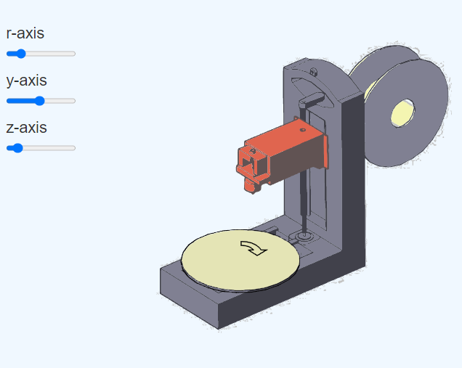

**Fig 2: Playing with Axes**

**Result:** Thus the simulation on construction of polar 3D printer is completed & movement of axis along X, Y, & Z has been studied.